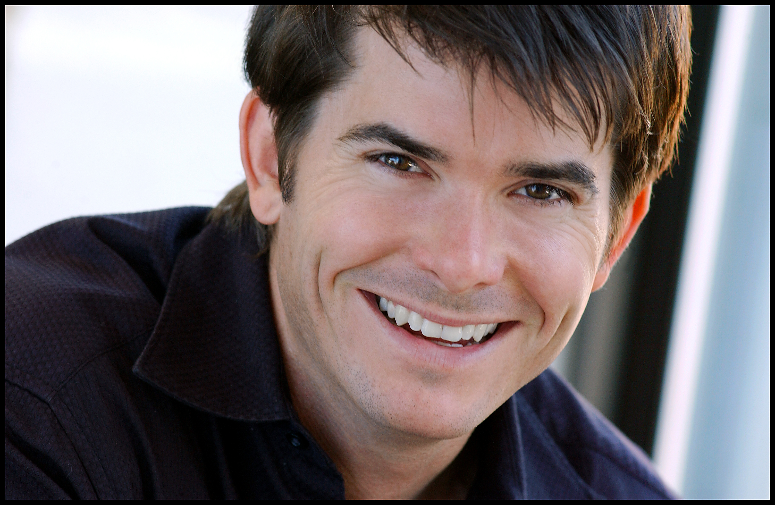
Kevin Kraft
Wgt: 150
Hgt: 5’’10”

For Agents click “Representation”at www.KevinKraftActing.com

SAG AFTRA AEA

FILM & TV
SHOWTIME NIGHTTIME Lead - On Air Host Showtime Nighttime Programming Host
REBELS AND REDCOATS Lead - Dr. Thatcher BBC & PBS
ALL MY CHILDREN Recurring - Tommy Brusard ABC
KISS OF A KILLER Supporting ABC MOW
ED Supporting Universal Studios
THE NANNY DIARIES Supporting Weinstein / Film Colony Dir Robert Pulcini
DUNSTON CHECKS IN Supporting 20th Cent Fox, Dir Ken Kwapis
WRITERS BLOCK Sketch Comedy Casty Haase Pilot
THE LATE SHOW (LETTERMAN) Recurring - Comic Bits CBS
LATE NIGHT WITH CONAN O’BRIEN Recurring – Comic Bits NBC
RIPPLE Lead NYU Graduate Film
SANDRA Lead NYFA Advanced Film
THE PARK Lead NYU Graduate Film

BROADWAY
A FUNNY THING...FORUM Hero SB Original Broadway Revival Cast, Dir Jerry Zaks
(w/ Nathan Lane & Whoopi Goldberg)
THE HUNCHBACK OF NOTRE DAME Ensemble Original Brodway Workshop Cast, Dir James Lapine

NEW YORK THEATRE
THE FARTISTE (NY Fringe Award) Joseph Pujol Original OFF-BW Cast (& NYFF Best Musical)
JOHNNY GUITAR Turkey SB Original OFF-BW Cast - Century Center
AMERICAN DREAMS Bob Ziak Original OFF-BW Cast - Lucille Lortel
PLANE CRAZY Clive Original Cast – Samuel Beckett Theatre
CARRIN BEGINNING Marc Chelsea Theatre/Riverside Stage

THEATRE
AS YOU LIKE IT Orlando and Amiens The Acting Company
SHE LOVES ME Georg The Arena Stage, Dir. Kyle Donnely
FLOYD COLLINS Homer Actors Theatre of Louisville
HOUDINI Harry Houdini Segal Center, Montreal (World Premier)
BARNUM Ringmaster & 8 other roles The Asolo
THE FULL MONTY Jerry West Virginia Public Theatre
THE WEDDING SINGER Robbie West Virginia Public Theatre
JOSEPH…DREAMCOAT Baker & Brother North Shore Music Theatre Dir Greg Ganakas

BAREFOOT IN THE PARK Paul St. Michael’s Playhouse
HAY FEVER Simon Theatre Virginia
DAS BARBECU Sigfried, Albrich, etc West End Theatre & Arvada Center
DR. JEKYL & MR. HYDE Harris Paper Mill Playhouse, Dir. Phil McKinley
GREASE Eugene Kansas City Starlight, Dir. Phil McKinley
THE MARRANO Raphael Massachusetts Rep, Dir. Mark Bramble

TRAINING
Michael Howard Studios (Michael Howard) Caryn West (Film & TV)
David Sabella (Voice Bari–tenor) Rob Decina (Acting for TV)
USC BFA (Tad Danielewski & Stephen Book) Beverly Hills Playhouse (Gloria Gifford)

SKILLS
Songwriter (www.KevinKraftMusic.com), Sing, Play Guitar, Lute, Harmonica. Roller Blading, Marathon Runner .
Some Circus Skills (juggling, etc.) & Magic. Dialects: South African, Irish, Cockney, Standard British. Some Japanese.

